Kinnear Justin Wong

**Description Of Scripts**

AstarWaypoint.cs finds the path needed for the AI to walk to random areas of the map that are available to the player

DisplayEditorGUI.cs takes care of displaying the GUI of Unity for display of the level eitor components of the Level Editor scene

EditLevel.cs does editing of the Level Editor in the LevelEditor scene from mouse to world using a Unity raycast

LoadLevels.cs loads the level of the respective level from a textfile into memory

NodeContainer.cs is a class container to contain notes that the A* pathfinding AI uses

NodeDetails.cs is a class container that stores the respective prefab’s level tile’s swappable tile objects while in the Level Editor

ToggleOutline.cs simply toggles the outline shader to enable or disable the outline shader upon highlighting the tile with your mouse in the Level Editor

WaypointAIScript.cs simply obtains the waypoints from the corresponding waypoint level textfile and stores the waypoints into a list for the AI to tranverse through

**A* AI**

A* pathfinding is integrated into the AI of the random movement AI. The AI picks a random spot on the map and pathfinds its way there

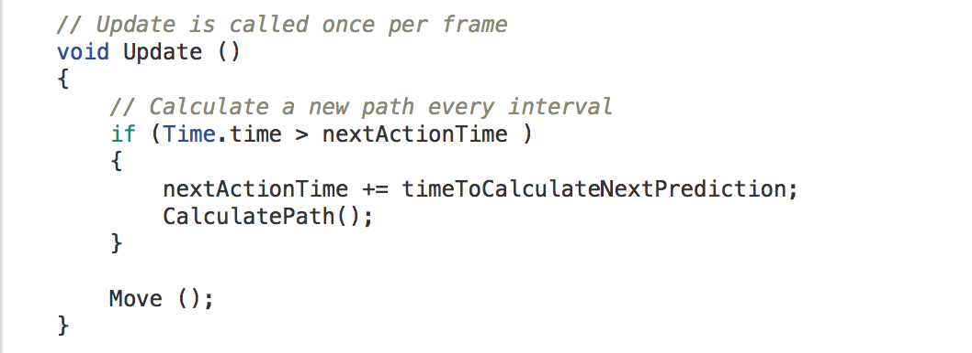

CalculatePath() runs at an interval set in the Unity Editor. CalculatePath() is to calculate the desired path of the AI towards a target by the A* algorithm. The method used was obtaining map data from the textfile of a level and then converting it into areas that the AI can walk on.

Move() moves the AI towards targeted positions in the list of nodes stored.

**Waypoint AI**

The Waypoint AI does waypoint movement by obtaining it’s waypoints from a separate textfile from the level text file. The waypoint text file has a exact file name to the Level but with a “PatrolWayPoints” appending to the end of the level’s name

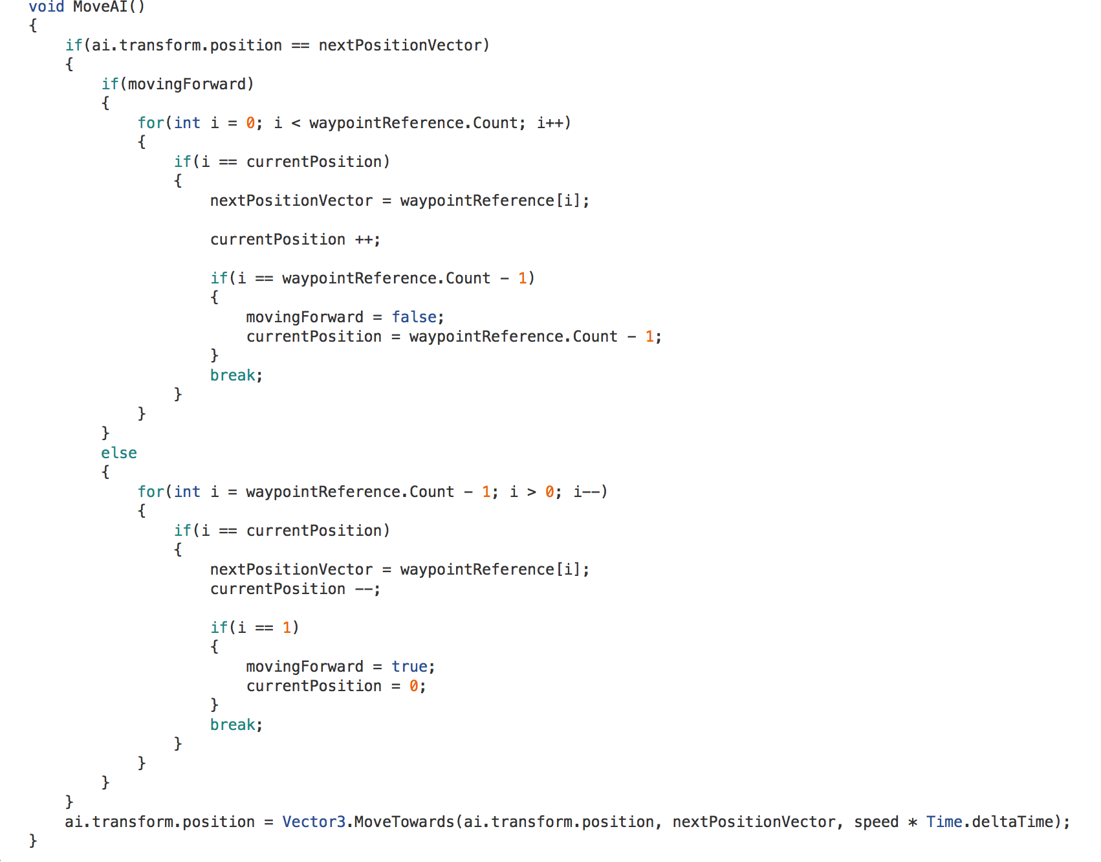

MoveAI() is to traverse through the list of waypoints that were set in the Level Editor in the particular level. The AI “Ping-Pong’s” back and forth towards the AI’s respective positions in the list.